CSCI434 COLL 400 Capstone
Sam · Levi · Lauren · Alex · Timmy · Joe
William & Mary
Williamsburg, Virginia, USA

1. Abstract
Modern internet traffic is predominantly encrypted, making passive monitoring of user activity difficult but not impossible. Traffic metadata such as packet timing, packet sizes, transport protocol use, and encrypted-service indicators can still reveal behavioral patterns associated with specific websites. In this report, we classify encrypted website traffic from packet capture files using metadata features rather than payload contents or URLs. Our dataset uses seven website classes. Our feature extractor includes timing and length statistics, throughput rates, TCP/UDP rates and ratios, TLS indicators, and QUIC/UDP-443 indicators. Logistic Regression is used as a baseline and Random Forest is used as the proposed model. On our current test set, Logistic Regression achieved 0.64 accuracy and 0.66 macro F1, while Random Forest achieved 0.86 accuracy and 0.86 macro F1.
Keywords: network traffic classification, website fingerprinting, encrypted traffic, random forest, logistic regression, packet metadata

2. Introduction
As internet use continues to grow, so does the importance of understanding network behavior. Packet inspection historically allowed analysts to inspect traffic contents, but widespread HTTPS/TLS adoption makes payload-based classification infeasible for most modern browsing sessions. Even when payloads are encrypted, packet metadata is still observable. Timing, packet length distributions, protocol mix, and use of services such as TLS or QUIC can act as a website fingerprint.
This project studies whether packet metadata alone can identify the website associated with a browsing session. We use manually collected .pcapng captures, derive labels from filenames, extract metadata features with Scapy, and compare Logistic Regression against Random Forest. In this experiment, we use seven different websites.

3. Proposed Method

Data Collection and Class Filtering
Packet captures were collected manually using Wireshark and stored as .pcapng files. The dataset contains 140 captures across seven classes.
Class | Captures Used
YouTube | 20
Amazon | 20
Bose | 20
GitHub | 20
Indeed | 20
New York Times | 20
Tribe Careers | 20
Total | 140

Feature Extraction
Our current feature extractor uses Scapy to parse each pcapng file. Labels are determined by the filename. The script avoids raw count features such as total packet count, total bytes, and raw duration as model inputs. This is because we don’t want the length of the sessions to have any effect on the prediction. Instead, duration-sensitive signals are normalized as rates or ratios so longer captures do not automatically receive larger feature values.
The model uses 28 features:
- Timing statistics: interval_mean, interval_stdev, interval_min, interval_max, interval_p25, interval_median, interval_p75, interval_p90.
- Packet length statistics: length_mean, length_stdev, length_min, length_max, length_p25, length_median, length_p75, length_p90, most_common_length.
- Throughput rates: packets_per_second, bytes_per_second.
- Transport protocol rates: tcp_packets_per_second, udp_packets_per_second.
- Encrypted traffic indicators: tls_packets_per_second, quic_packets_per_second, tls_packet_ratio, tls_or_quic_packet_ratio, quic_udp_443_ratio.
- Protocol composition ratios: tcp_packet_ratio, udp_packet_ratio.
QUIC is approximated as UDP traffic using port 443. This is a practical metadata feature because encrypted HTTP/3 traffic often uses UDP/443. TLS detection depends on Scapy layer recognition, so the model also includes port and protocol based features that are more robust when TLS parsing is incomplete.

Classification Models
Two classifiers are trained using scikit-learn. Logistic Regression serves as a linear baseline and is trained on standardized features with max_iter=1000. Random Forest is the proposed method and uses 200 decision trees with random_state=42. Random Forest is well suited for this task because it can capture non-linear interactions between timing, length, and protocol features, and it can provide feature importance estimates for interpretation.

4. Evaluation

Experimental Setup
The 140-sample dataset was split with stratification into training, validation, and test subsets. The resulting split contained 84 training samples, 28 validation samples, and 28 held-out test samples. Accuracy and macro-averaged F1-score are reported on the test set. Macro F1 is important because it weights each website class equally.

Results
The updated results show a clear improvement from the richer normalized feature set. Random Forest substantially outperformed Logistic Regression on the held-out test set.
Model | Accuracy | Macro F1 | Notes
Logistic Regression | 0.64 | 0.66 | Standardized features, linear baseline
Random Forest | 0.86 | 0.86 | 200 estimators, normalized metadata features

Random Forest also achieved 0.86 validation accuracy and 0.85 validation macro F1, indicating that the test result is consistent with the validation split for this set of data.
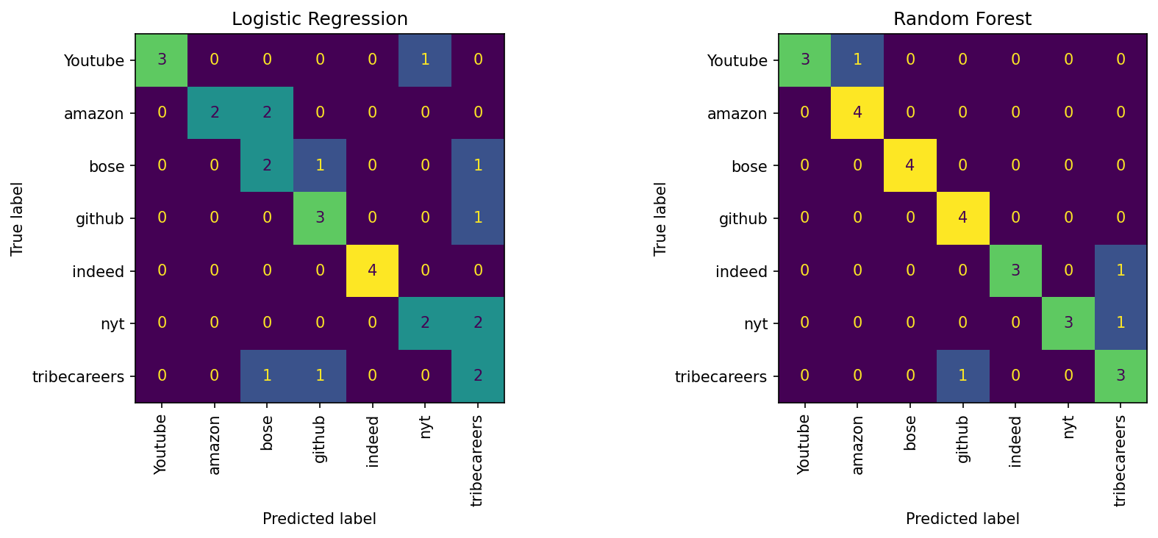

Feature Importance
The Random Forest feature importance plot now reflects the expanded feature set. The highest-ranked features include packet length percentiles, TCP/UDP ratios, TLS/QUIC indicators, and throughput rates.
Rank | Feature | Importance
1 | length_p90 | 0.0756
2 | udp_packet_ratio | 0.0683
3 | tls_or_quic_packet_ratio | 0.0536
4 | tcp_packets_per_second | 0.0491
5 | tcp_packet_ratio | 0.0474
6 | length_p75 | 0.0450
7 | bytes_per_second | 0.0435
8 | quic_packets_per_second | 0.0415

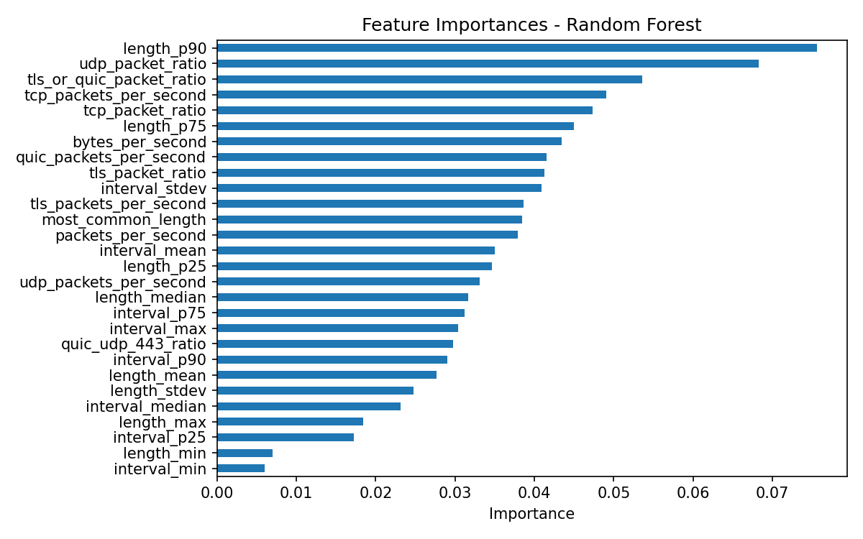

Prediction Graph
The prediction graph compares the encoded actual class sequence against the Random Forest predictions for the held-out test set. It provides a compact view of where the model agrees with disagrees from the true labels.
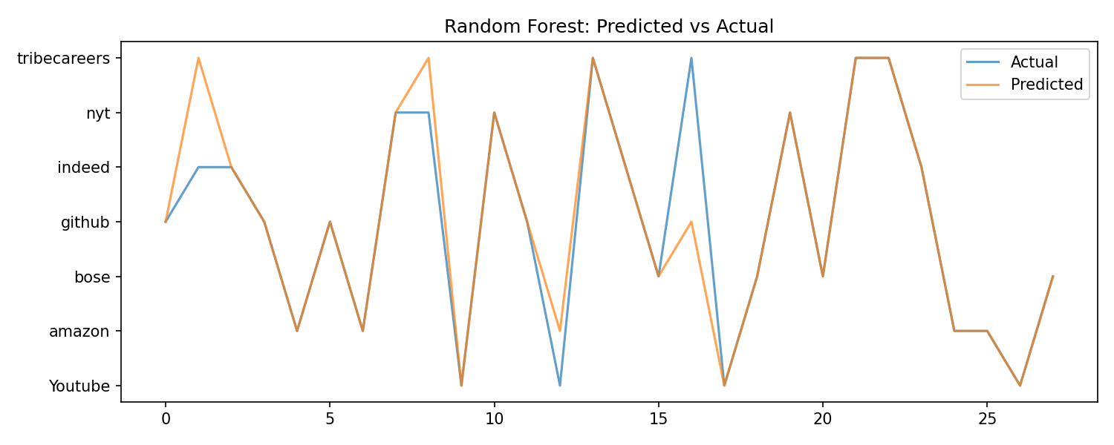

5. Discussion
This experiment demonstrates that metadata on encrypted network traffic can be used for website fingerprinting in this data set. Our original feature set included only raw packet count, total bytes, duration, packet count average, min, and max, interval average, min, and max. We were getting only 0.64 for accuracy in our Random Forest model. Removing raw packet count, total bytes, and duration reduced the risk that the classifier simply learns capture length. Replacing those raw quantities with rates and ratios lets the model compare traffic behavior across sessions that have different durations.
There are still some remaining errors, however. Some websites have overlapping traffic patterns, and a small dataset of roughly 20 captures per class is not enough data to fully represent the variability of real browsing sessions. Our results, therefore, are more just evidence that metadata can be used to make predictions, and we do not yet have a production-ready model.

6. Limitations and Future Work
There are several limitations. First, the dataset is still small, with only 140 captures. Second, the evaluation uses a single stratified split, so performance may vary across alternative splits. Third, the current feature set remains aggregate and does not model packet order beyond summary statistics.
Future work should add stratified k-fold cross-validation, collect more captures per website, and add sequence-oriented features such as the first 50 packet lengths and inter-arrival times. Direction-aware features would also be valuable if local versus remote endpoints can be inferred reliably. A 1D convolutional neural network over packet sequences may become more useful once the dataset is substantially bigger.

7. Conclusion
This report shows that encrypted website traffic can be classified using metadata features alone. With seven classes and 140 captures, Logistic Regression achieved 0.64 accuracy and 0.66 macro F1, while Random Forest achieved 0.86 accuracy and 0.86 macro F1. The strongest features include packet length percentiles, protocol ratios, throughput rates, and TLS/QUIC indicators. These findings reinforce the privacy implications of encrypted traffic metadata: even without URLs or payloads, browsing activity can remain distinguishable from packet-level behavior.

8. References
[1] A. Hintz, "Fingerprinting websites using traffic analysis," Privacy Enhancing Technologies, 2002.
[2] T. Wang and I. Goldberg, "Improved website fingerprinting on Tor," ACM CCS, 2013.
[3] L. Breiman, "Random forests," Machine Learning, vol. 45, no. 1, pp. 5-32, 2001.
[4] Wireshark Foundation, "Wireshark Network Analyzer," https://www.wireshark.org, 2024.
[5] Scapy Project, "Scapy packet manipulation program," https://scapy.net.

